

**Project Initialization and Planning Phase**

|  |  |
| --- | --- |
| Date | 09 July 2024 |
| Team ID | 739734 |
| Project Name | Evolving efficient classification patterns in Lymphography |
| Maximum Marks | 3 Marks |

**Define Problem Statements (Customer Problem Statement Template):**

The current medical diagnosis process for lymphography data can be challenging and timeconsuming. Patients, particularly those undergoing lymph node analysis, face issues such as inconsistent diagnosis results and a lack of automated tools to assist in the classification of lymphography data. These challenges can lead to misdiagnosis and delay in treatment, potentially affecting patient outcomes and satisfaction. To enhance the diagnostic process and improve patient care, we aim to address these issues. By understanding the specific challenges faced during lymphography diagnosis and implementing an automated classification tool, we can create an efficient, user-friendly experience that aligns with the needs of healthcare professionals and patients, fostering trust and reliability in medical diagnostics.



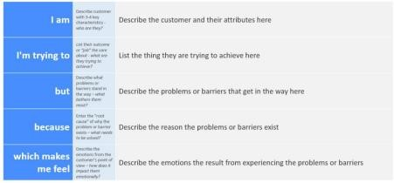

Reference: https://miro.com/templates/customer-problem-statement/ **Example:**

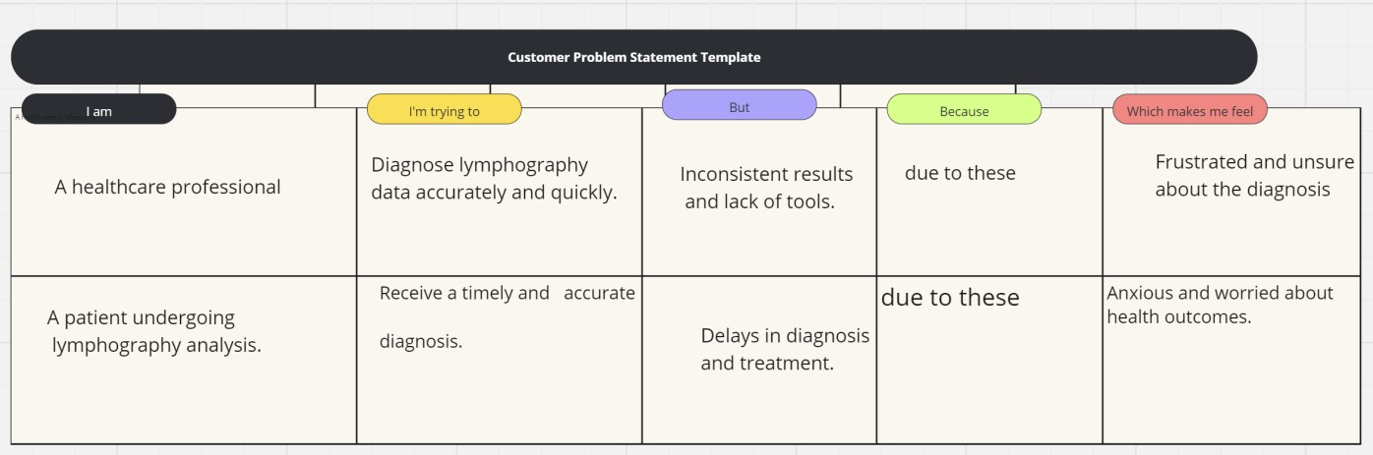



|  |  |  |  |  |  |
| --- | --- | --- | --- | --- | --- |
| **Problem Statement (PS)** | **I am (Customer)** | **I’m trying**  **to** | **But** | **Because** | **Which makes me feel** |
| PS-1 | A healthcare professional | Diagnose lymphograp hy data accurately and quickly. | Inconsi stent results and  lack of tools. | Due to these | Frustrated and unsure about the diagnosis |
| PS-2 | A patient undergoing lymphograph y analysis. | Receive a timely and accurate diagnosis. | Delays  in  diagno sis and treatm ent. | Due to these | Anxious and worried about health outcomes. |



# Project Objectives

* Develop an automated tool to classify lymphography data with high accuracy.
* Improve the diagnostic process by providing consistent and reliable classification results.
* Enhance patient care by reducing the time taken for diagnosis and treatment.
* Create a user-friendly interface for healthcare professionals to interact with the classification tool.

# Project Overview

**1.** The Lymphography Classification Tool project focuses on developing an automated system to classify lymphography data, which helps in the accurate and timely diagnosis of lymph node conditions. The project involves the following key components:

* Data Collection: Gather lymphography data from various medical sources.
* Data Preprocessing: Clean and preprocess the data to ensure it is suitable for model training.
* Model Development: Train a machine learning model to classify lymphography data accurately.
* Web Application: Develop a web-based interface for healthcare professionals to use the classification tool.
* Testing and Validation: Test the tool to ensure its accuracy and reliability in real-world scenarios.

## Expected Outcomes

* A fully functional and accurate lymphography classification tool.
* Reduced diagnosis time and improved accuracy of lymphography data analysis.
* Increased trust and satisfaction among healthcare professionals and patients.
* Enhanced efficiency in the medical diagnostic process.